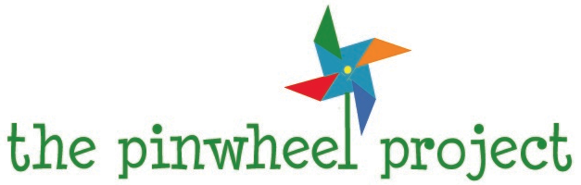

THE BURIAL FUND

The Pinwheel Project prides itself in working to fill the various needs of hospitalized children and their families whenever they may arise. Sadly, one of these needs has been on the increase lately and we are eager to try to provide some relief. Too often, despite the best efforts of medical professionals, children die of their diseases or injuries. Quite honestly, there is probably no other event in life that compares to the horror of losing a child. Just the thought of it strikes such terror in the hearts of parents and families. We do not want to think about it ever happening to anyone, let alone to us. But unfortunately it is a reality. For these families, the crushing loss of a child is compounded by the problem of paying for a funeral. For many, it presents a hardship that is simply insurmountable.

That is why we are working to establish a restricted fund for the sole purpose of assisting parents to pay for this final goodbye to a beloved child. All funds will be paid directly to the funeral home or cemetery insuring that all assistance goes directly to helping the family’s burial costs. With your help, we can work together to bring some comfort to the many loved ones who long to say a meaningful farewell to a young, precious life that surely ended too soon.

This is an opportunity to provide an incredible gift for another family while helping to celebrate the life of their child. For more info, please feel free to contact us.

